|  |  |
| --- | --- |
| **Name:** | **Waleed Afzal** |
| **Roll Num:** | **23P-0566** |
| **Section:** | **4C** |
| **Course:** | **Operating System – Lab** |
| **Activity:** | **Lab Task 4 – Remaining Tasks** |

**Remaining Tasks (8-11)**

**Task 8:**

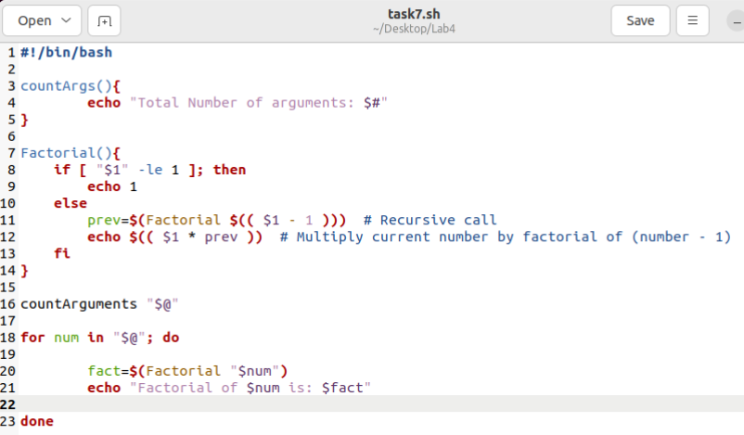

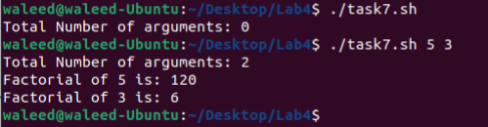

**Task 9:**

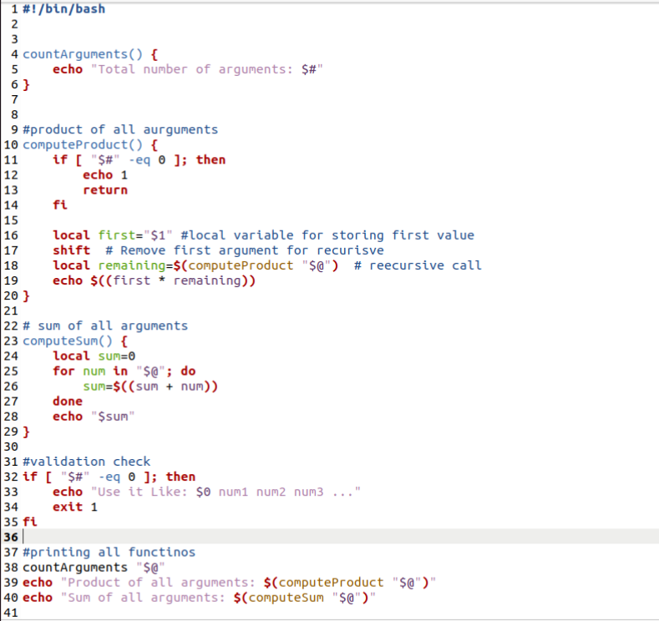

**Task 10:**

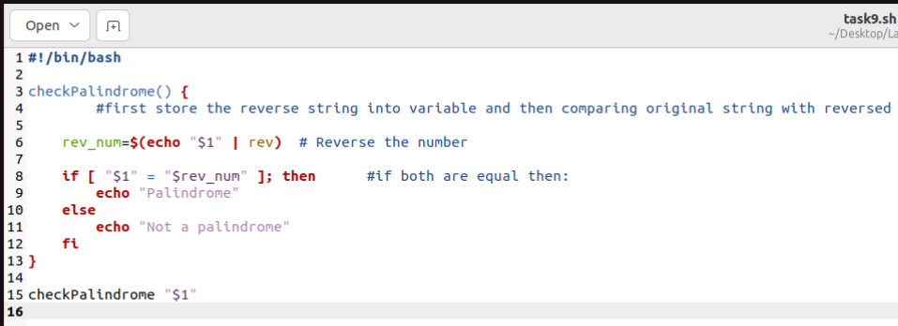

**Task 11:**

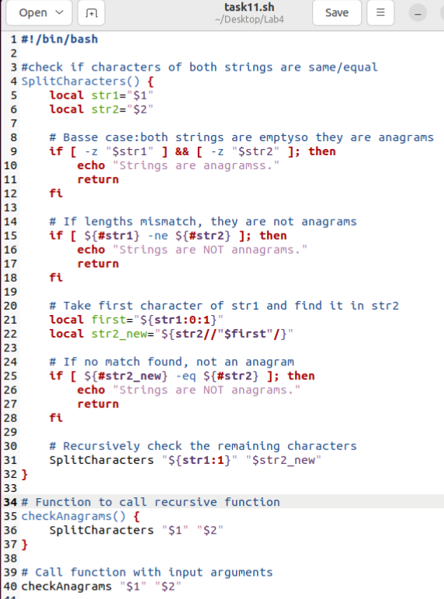

**Reference Used:**

1. <https://stackoverflow.com/questions/27791251/get-first-character-of-a-string-shell>
2. <https://www.geeksforgeeks.org/shell-script-to-split-a-string/>
3. <https://unix.stackexchange.com/questions/303960/index-a-string-in-bash>
4. <https://stackoverflow.com/questions/50915121/what-is-the-best-way-to-override-an-existing-shell-command>